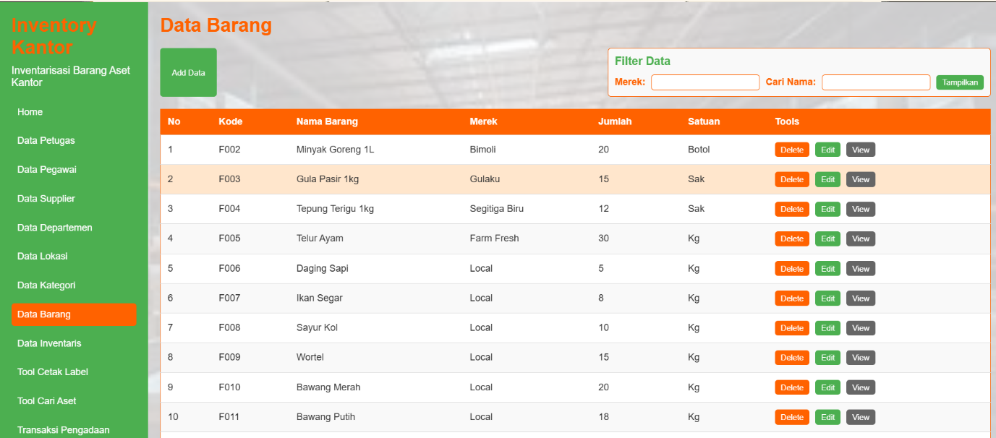**Tampilan Inventory Management 2**

* **Tampilan di Phpmyadmin**

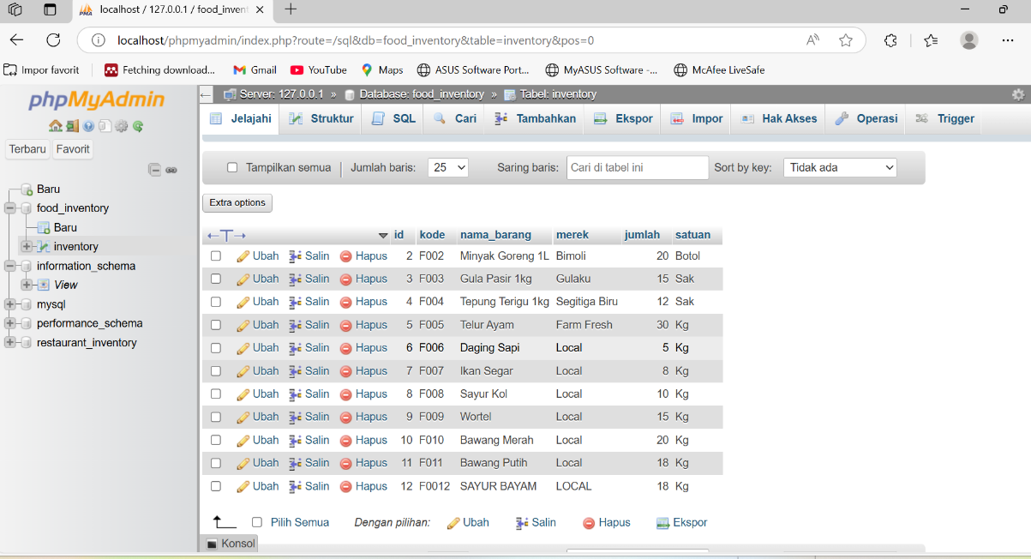

<http://localhost/inventory-management-system>